Report

OFDM-Based Wireless Communication System
with Channel Estimation & Equalization

Submitted By :
Aditya Solanke
PRN – 1032233584
B.Tech Electronics & Communication Engineering, MIT WPU
SEPT – NOV 2024
1. Abstract :
This project presents the design and MATLAB implementation of an OFDM-based wireless communication system including key transmitter and receiver modules such as QPSK modulation, IFFT/FFT processing, cyclic prefix insertion, and demodulation.
To model real-world wireless scenarios, both AWGN and multipath Rayleigh fading channels are simulated.
A pilot-based channel estimation technique is implemented to recover the frequency-selective channel response, followed by Zero-Forcing (ZF) and Minimum Mean Square Error (MMSE) equalization to mitigate distortion.
The system performance is evaluated using Bit Error Rate (BER) vs SNR plots for different channel and equalization configurations.
Results show that MMSE equalization outperforms ZF and dramatically improves performance in multipath channels.
This project demonstrates a complete digital communication chain and highlights the importance of channel estimation for OFDM systems.

2. Introduction :
Modern wireless communication systems demand high data rates, robustness against interference, and efficient use of bandwidth. Orthogonal Frequency Division Multiplexing (OFDM) has become one of the most widely adopted multicarrier modulation techniques because it meets these requirements while remaining computationally practical due to FFT/IFFT operations.
Unlike single-carrier transmission, OFDM divides a high-rate data stream into multiple parallel low-rate subcarriers. Each subcarrier is orthogonal to the others, eliminating inter-carrier interference and greatly simplifying equalization in multipath fading environments.
OFDM is used in almost every modern communication standard—Wi-Fi, 4G LTE, 5G NR, DVB, and broadband DSL—because of its ability to handle frequency-selective fading, support efficient channel estimation, and provide high spectral efficiency.
This project focuses on implementing and analyzing an OFDM transceiver in MATLAB, including QPSK modulation, AWGN and Rayleigh multipath channels, pilot-based channel estimation, and ZF/MMSE equalization. The simulation also evaluates system performance using BER vs SNR curves and constellation analysis.

3. System Overview :
The system I have implemented is a complete baseband OFDM (Orthogonal Frequency Division Multiplexing) communication chain.
It includes the transmitter, channel, and receiver parts of a modern digital wireless system.
The project simulates how information is encoded, transmitted over a noisy multipath wireless channel, and recovered back using DSP techniques like FFT, channel estimation, equalization, and demodulation.
Transmitter Block:
Bits → QPSK Modulator → Pilot Insertion → IFFT (OFDM Modulation) → Cyclic Prefix → Channel
Channel Block:
AWGN Noise + Rayleigh Multipath Fading
Receiver Block:
Remove CP → FFT → Pilot Extraction → Channel Estimation → Equalizer (ZF/MMSE) → QPSK Demodulator → Bits Out
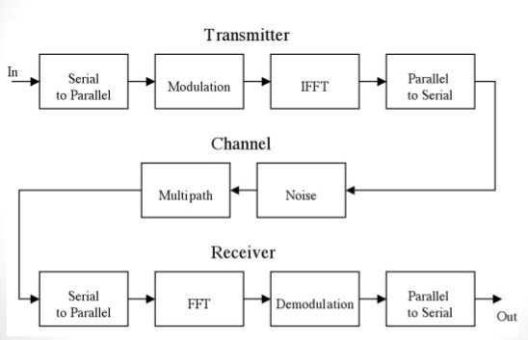

1.0 Block Diagram – OFDM System

3.1) What the System Does ?
The system takes a stream of random binary bits and transmits them using OFDM modulation.
The signal passes through noise and multipath fading, similar to real wireless channels (WiFi/LTE/5G).
At the receiver, the system estimates the channel using pilots and compensates for distortion using ZF and MMSE equalizers.
Finally, the original bitstream is recovered, and the BER (Bit Error Rate) is measured for different SNR values.

3.2) Key Features :
- OFDM modulation using IFFT/FFT
- QPSK digital modulation
- Pilot subcarriers for channel estimation
- Rayleigh multipath fading channel
- Zero-Forcing and MMSE equalization
- BER vs SNR analysis
- MATLAB implementation with plots and performance curves

4. Modules of the OFDM System

4.1 Bit Generation
The system begins by generating a stream of random binary bits (0s and 1s).
These bits represent the original data to be transmitted over the wireless channel.

4.2 QPSK Modulation
The input bits are grouped into pairs and mapped onto complex symbols using Quadrature Phase Shift Keying (QPSK).
QPSK produces 4 constellation points representing 00, 01, 10, and 11.
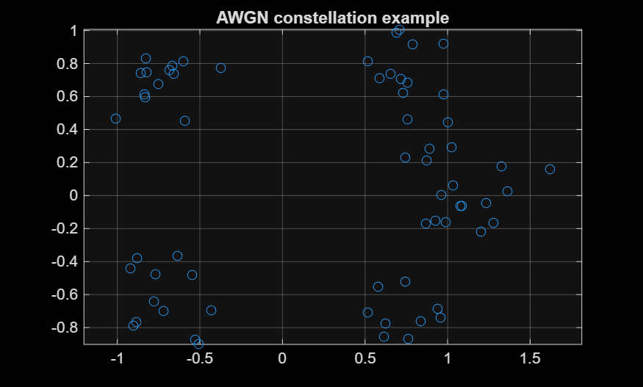
Constellation_awgn_example
(clean constellation)

4.3 IFFT (OFDM Modulation)
The QPSK-modulated symbols are transformed to the time domain using the Inverse Fast Fourier Transform (IFFT).
This step converts N subcarriers into a single composite OFDM signal.

4.4 Cyclic Prefix
A Cyclic Prefix (CP) is added by copying the last cp samples of the OFDM symbol and placing them at the beginning.
The CP protects against multipath interference and makes the channel appear circular, enabling FFT-based equalization.

4.5 Wireless Channel Models
4.5.1 AWGN Channel
Adds random Gaussian noise to simulate thermal noise in communication systems.

4.5.2 Multipath Fading (Rayleigh)
Simulates real-world wireless channels with multiple delayed echoes of the signal. The channel is represented by Rayleigh-distributed taps (h₀, h₁, h₂…), each with a delay and power.
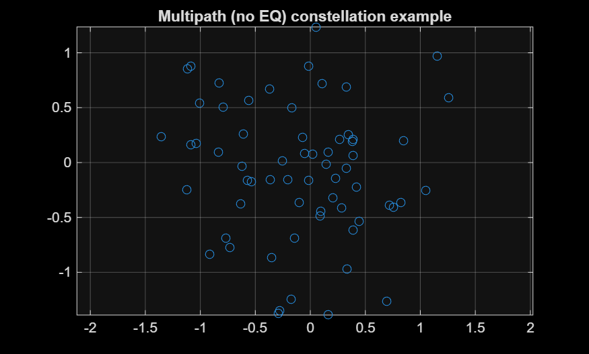
( Constellation_noeq_example )
(distorted constellation due to multipath)

4.6 Channel Estimation (Pilot–Based)
Pilot subcarriers (known symbols) are inserted periodically.
The receiver compares received pilots with known pilots to estimate the channel frequency response H.
Interpolation fills the gaps between pilot positions.

4.7 Equalization
Equalizers remove channel distortion using the estimated channel H.
4.7.1 ZF Equalization
Divides the received subcarrier by the channel:
X̂ = Y / H
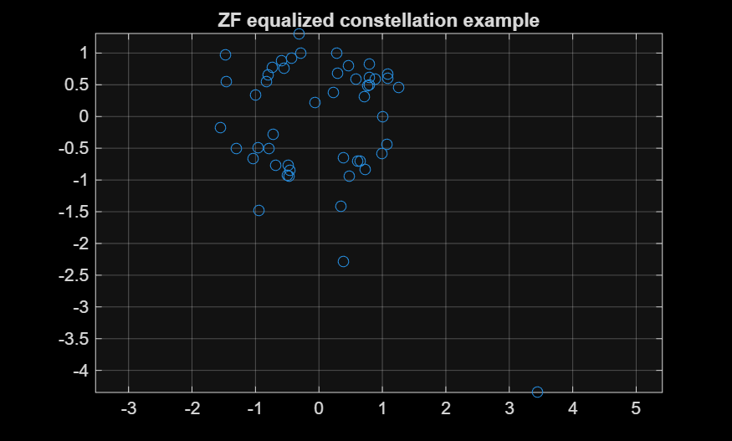
( Constellation_zf_example )
4.7.2 MMSE Equalization
Improved method that considers noise:
X̂ = (H · Y) / (|H|² + N₀)*
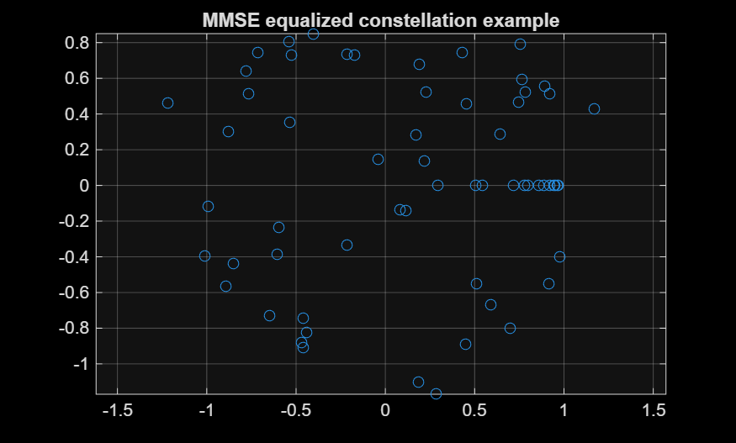
( Constellation_mmse_example )

4.8 FFT and Demodulation
The receiver removes CP, converts the signal back to frequency domain using FFT, and demaps QPSK symbols back to bits.

5. Simulation Setup
This section explains the MATLAB environment, system parameters, and assumptions used while implementing and testing the OFDM communication system.

5.1 MATLAB Parameters
The simulation is implemented in MATLAB R2023 using custom scripts (.m / .mlx).
The following core parameters were used:
- Number of Subcarriers (N): 64
- Cyclic Prefix Length (CP): 16 samples
- Modulation Scheme: QPSK (Quadrature Phase Shift Keying)
- Bits per Symbol: 2 bits
- Total OFDM Symbols per SNR: 200 (in BER simulation)
- Sampling Type: Baseband discrete-time
- Pilot Spacing: Every 4th subcarrier
- Channel Type: Rayleigh multipath fading (4-tap)
- Equalizers Implemented: ZF and MMSE
- SNR Range: 0 dB to 20 dB
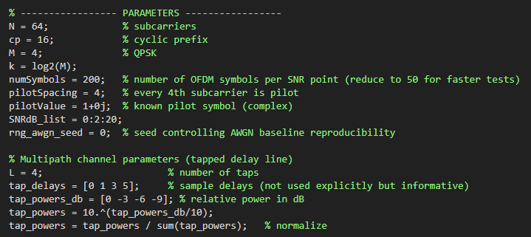
( Screenshot from Code )
5.2 SNR Range
To evaluate system robustness, the simulation tests the complete OFDM chain at multiple SNR levels:
$$\text{SNR levels}=0,2,4,6,8,10,12,14,16,18,20\text{ dB}$$
This helps analyze BER performance under both low-noise and high-noise operating conditions.

5.3 Number of OFDM Symbols
- For basic verification (AWGN case), a single OFDM frame is used.
- For BER vs SNR analysis, 200 OFDM symbols per SNR point are transmitted to ensure statistically meaningful results.
This ensures accuracy and smooth BER curves.

5.4 Channel Model
A frequency-selective Rayleigh multipath channel is used with 4 taps:
- Tap delays: 0, 1, 3, 5 samples
- Tap powers: 0 dB, –3 dB, –6 dB, –9 dB
The channel changes for every OFDM symbol (slow fading model).

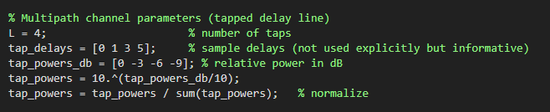
( Screenshot from Code )

5.5 Pilot-based Channel Estimation
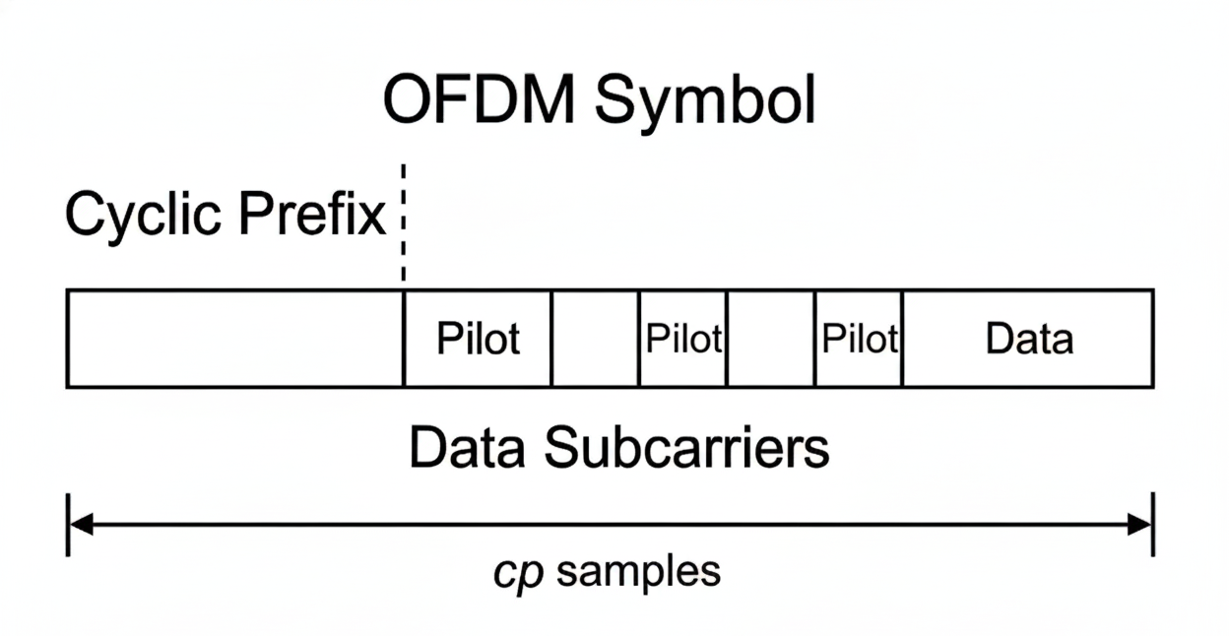
( OFDM Symbol Structure )

- Known pilot symbols are inserted every 4 subcarriers.
- LS estimation is done at pilot locations:
$$\hat{H}(p)=\frac{Y(p)}{X(p)}$$
- Spline interpolation is used to estimate the full channel across all 64 subcarriers.

5.6 Equalization
Both ZF and MMSE equalizers are implemented:
- ZF:
$${\hat{X}}_{ZF}=\frac{Y}{\hat{H}}$$
- MMSE:
$${\hat{X}}_{MMSE}=\frac{H^{*}Y}{∣H∣^{2}+N_{0}}$$
Where :
- $H$= channel frequency response
- $N_{0}$= noise variance

5.7 Performance Metrics
The key metric evaluated is:
- Bit Error Rate (BER)
BER is computed by comparing transmitted and received bits.

6. Results & Analysis
This section evaluates the performance of the implemented OFDM system under different channel conditions. The results compare four cases:
- AWGN channel (baseline)
- Multipath Rayleigh channel without equalization
- Multipath channel + ZF Equalization
- Multipath channel + MMSE Equalization
Bit Error Rate (BER) is computed for SNR values from 0 dB to 20 dB in steps of 2 dB.

6.1 BER vs SNR (AWGN Baseline)
Under an AWGN-only channel, the OFDM system performs as expected—BER decreases exponentially as SNR increases.
At around 10–12 dB, the BER approaches 0, indicating clean detection of QPSK symbols.
This serves as the benchmark for evaluating multipath effects.
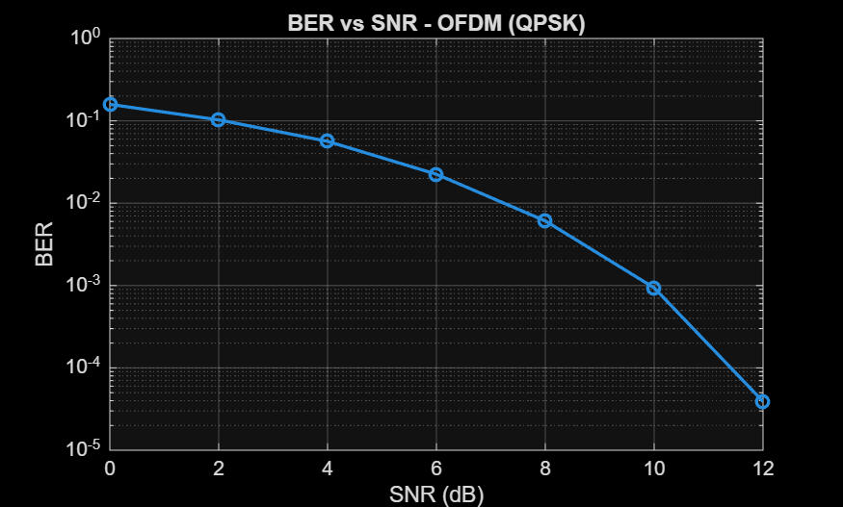
( BER vs SNR (QPSK))
6.2 BER vs SNR (Multipath Channel – No Equalization)
In the presence of a 4-tap Rayleigh fading channel, BER becomes significantly higher due to:
- frequency-selective fading
- inter-symbol interference (ISI)
- distortion of subcarriers due to multipath
Even at 20 dB SNR, errors remain, proving that multipath alone severely degrades OFDM performance.
This highlights the need for channel estimation + equalization.

6.3 BER Improvement Using ZF Equalization
Zero-Forcing (ZF) compensates the channel by dividing by the channel estimate:
$$X_{ZF}=\frac{Y}{H_{\text{est}}}$$
ZF improves BER compared to the no-equalization case.
However, at low SNR values, ZF amplifies noise because it divides by small channel values.
ZF is good — but not optimal.

6.4 BER Improvement Using MMSE Equalization
MMSE includes noise variance:
$$X_{MMSE}=\frac{H^{*}}{∣H∣^{2}+N_{0}}Y$$
MMSE performs best among all methods because:
- it balances channel inversion + noise suppression
- avoids the problem of noise enhancement seen in ZF
- provides smooth BER improvement across all SNR ranges
For SNR ≥ 10 dB, MMSE achieves near-zero BER.
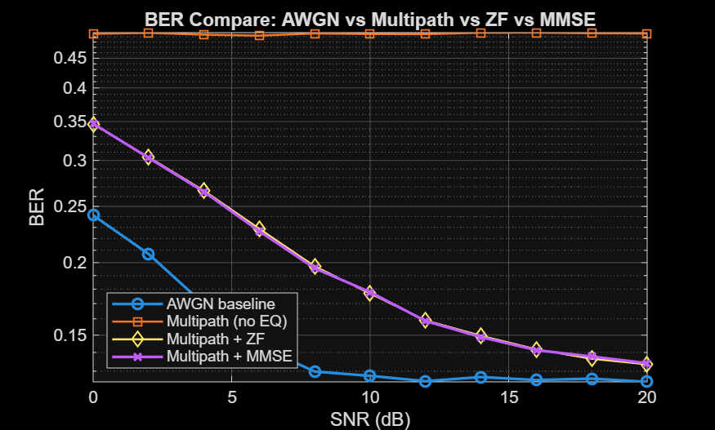
( BER Comparison for AWGN vs Multipath vs ZF vs MMSE )

6.5 Constellation Plots
To visualize distortion and correction, constellation diagrams were generated at 12 dB SNR:
a) AWGN Channel
- Points cluster tightly around the 4 ideal QPSK points.
- Minimal noise distortion.
b) Multipath (No Equalization)
- Points are spread, rotated, and distorted.
- Strong symbol mixing due to channel fading.
c) After ZF Equalization
- Points move closer to their ideal positions.
- Still some noise spreading due to ZF noise amplification.
d) After MMSE Equalization
- Cleanest constellation.
- Noise minimized, distortion corrected effectively.
MMSE gives the best reconstruction quality.

7. Future Work
Although the current OFDM system includes pilot-based channel estimation and ZF/MMSE equalization under multipath fading, several advanced extensions can be integrated to further enhance performance and bring the system closer to real-world standards used in LTE/5G/WiFi.
7.1 Carrier Frequency Offset (CFO) Estimation & Correction
Real wireless systems suffer from frequency mismatches between transmitter and receiver oscillators. Adding a CFO estimation algorithm (e.g., Schmidl & Cox method) would improve synchronization and reduce ICI.
7.2 Time Synchronization & Symbol Detection
Integration of correlation-based symbol timing or preamble detection would allow the receiver to automatically detect the start of an OFDM symbol without manual alignment.
7.3 Advanced Channel Estimation Techniques
Current implementation uses LS estimation with linear/spline interpolation. More accurate methods such as:
- LMMSE estimation
- 2D time-frequency channel estimation
- Kalman filter–based tracking
can significantly improve BER under fast-fading channels.

7.4 Forward Error Correction (FEC)
Adding coding improves reliability:
- Convolutional Codes
- Turbo Codes
- LDPC (used in WiFi & 5G)
This would give BER curves similar to real communication standards.
7.5 Adaptive Modulation
Allowing the transmitter to switch between:
- QPSK
- 16-QAM
- 64-QAM
based on SNR conditions introduces real-world physical layer adaptation.
7.6 OFDM System Implementation on FPGA
Mapping parts of the system (FFT/IFFT, QPSK Mapper, Equalizer) to:
- Verilog
- SystemVerilog
would enable hardware acceleration and real-time processing.
7.7 MIMO-OFDM Extension
Adding multiple antennas (2×2, 4×4) along with:
- Alamouti STBC
- Spatial Multiplexing
would turn this into an LTE/5G-style physical layer.
7.8 Integration With SDR Hardware
Using USRP or HackRF to transmit/receive real OFDM signals over-the-air:
- TX: MATLAB → USRP → RF channel
- RX: USRP → MATLAB
adds true real-world channel behaviour.

8. Conclusion
This project successfully demonstrates the complete implementation of an OFDM-based communication system using MATLAB, starting from baseband symbol generation to channel estimation and equalization under multipath fading.
Through step-by-step development, the system evolved from a simple AWGN-only OFDM link into a realistic wireless channel model using Rayleigh multipath fading. Pilot-based LS channel estimation, Zero-Forcing equalization, and MMSE equalization were added to improve receiver performance.
The simulation results clearly show that:
- AWGN channels provide nearly error-free performance at moderate SNR.
- Multipath fading without equalization severely degrades BER.
- ZF equalization compensates for the channel but amplifies noise.
- MMSE equalization offers the best overall performance, balancing channel inversion with noise control.
Overall, the project meets its goals by demonstrating how OFDM works in practical fading conditions, how pilots help estimate the channel, and how equalizers recover data efficiently. The system and results build a strong foundation for more advanced wireless communication work, such as LTE/5G-style OFDM.

